|  |
| --- |
| MIT and Lincoln Laboratory |
| Woodward and Generator Controller Modeling |
| Version 6 |
|  |
| **Kendall Nowocin** |
| **8/20/2015** |

This material is based upon work supported by the Assistant Secretary of Defense for Research and Engineering under Air Force Contract No. FA8721-05-C-0002 and/or FA8702-15-D-0001. Any opinions, findings, conclusions or recommendations expressed in this material are those of the author(s) and do not necessarily reflect the views of the Assistant Secretary of Defense for Research and Engineering.

© 2015 Massachusetts Institute of Technology.

Delivered to the US Government with Unlimited Rights, as defined in DFARS Part 252.227-7013 or 7014 (Feb 2014). Notwithstanding any copyright notice, U.S. Government rights in this work are defined by DFARS 252.227-7013 or DFARS 252.227-7014 as detailed above. Use of this work other than as specifically authorized by the U.S. Government may violate any copyrights that exist in this work.

|  |
| --- |
| This document outlines the secondary and primary controllers for a generator model and a small power system for unit tests using version 6. The tertiary controller is the user. Model development and unit test were performed to commission the Woodward generator controllers. |

Software:

The software/firmware is provided on an As-IS basis.

# Woodward with Modeled Primary Controllers and Prime Mover

## Milestone V6: 900 kW Generator

This demo tested the physical device controller to synchronize to the grid and have stable operation when changing the physical controller’s power set points. In addition, the previous version’s capabilities are still functional.

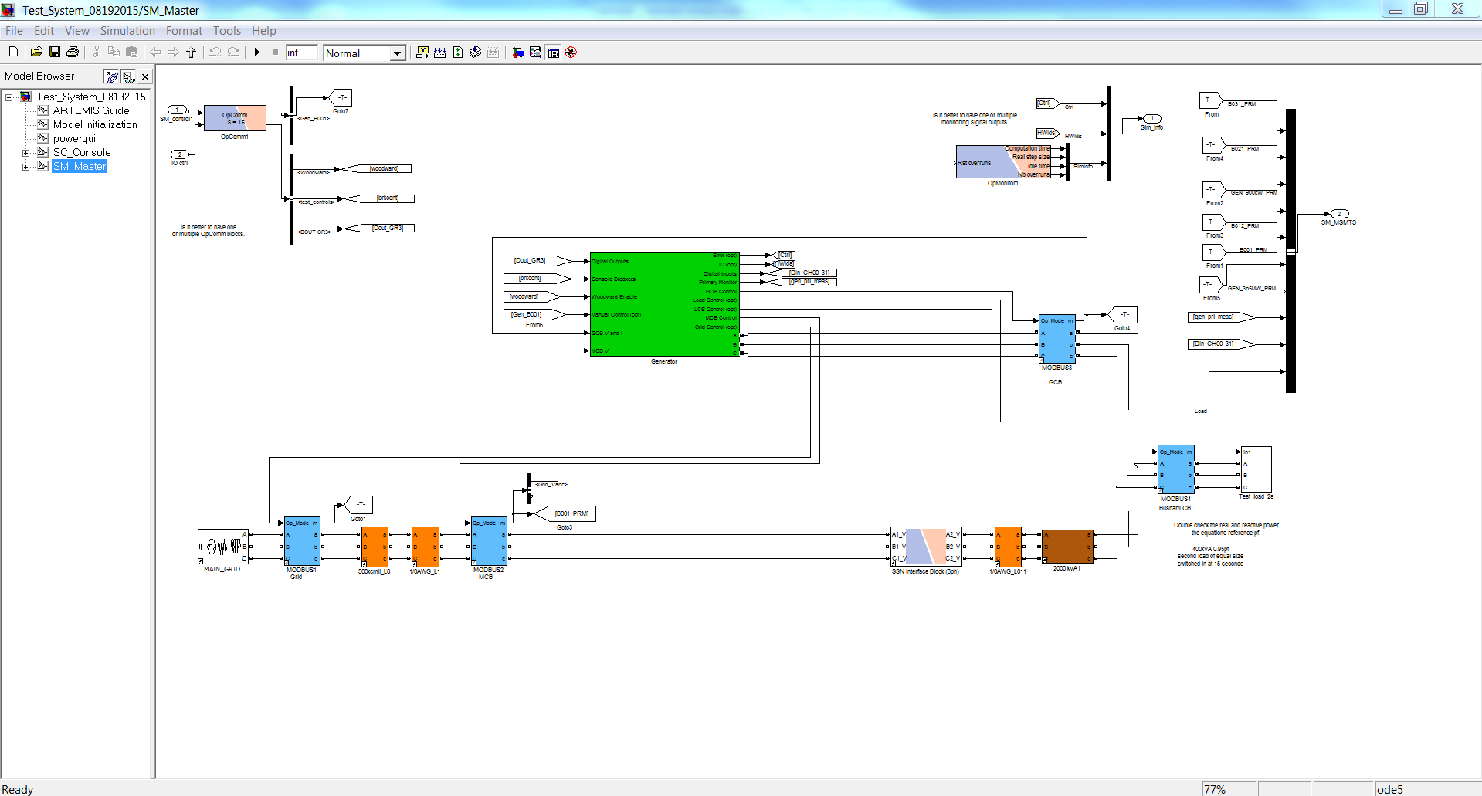

Figure 14: Milestone V6 model of Master Subsystem.

The Woodward in Milestone V6 is capable of operating as an emergency generator and in parallel with the mains. The attached photos zipped-up show various unit tests performed and the response.

There are two scopes the one on the left is the “Scope Gen” with breaker status, voltage and current connected at the generator terminals, and P and Q of the generator output, the one on the right is the “Scope Primary” with Prime Mover control, voltage of the field, terminal voltage, and rotor speed. The data coming over the Ethernet connection to the Simulink console and scopes exceed the buffered limit, therefore the Simulink scopes show some interpolated points due to the bandwidth though the real controllers are seeing a 50µs resolution waveform.

Pictures:

1a=> Startup command to the Woodward via Matlab, Woodward startup of the generator, Woodward stabilized to 480V, and Woodward close of the GCB (all without load)

1b=> Closing of the load breaker (400kVA 0.95pf), change load (800kVA 0.95pf), change load (400kVA 0.95pf), and shedding (800kVA 0.95pf) cause a fault and shutdown

1c=> Generator is started up again (VF mode) after the fault clears and is at stable operation, synchronization to the Grid and change to PQ mode occurs with a P setpoint of 400kW

1d=> While connected to the Grid the P setpoint is changed from 400kW to 100kW, 600kW, and 900kW

1e=> Generator Estop in Matlab is pressed, and the Grid stays connected to the load, the generator opens the GCB, and powers down

1f=> Generator is cleared of alarms, started up (VF mode), and within 10-14 seconds synchronizes and closes the GCB to the Grid, then stabilizes to the P setpoint of 400kW

1g=> Stable operation with the Grid

1h=> Stop button on the front panel pressed and GCB opens, 360s cool down, and generator shutdown

It is recommended to run the milestone model before altering portions of the code to fit a particular need.